Reaxys新平台登录步骤
Steps to log in the Reaxys new interface

- 点击http://www.reaxys.com或图书馆网站数据库链接，点击下面红圈处的“Go”
Go to the http://www.reaxys.com, then click “Go” under the institution login within the red circle.
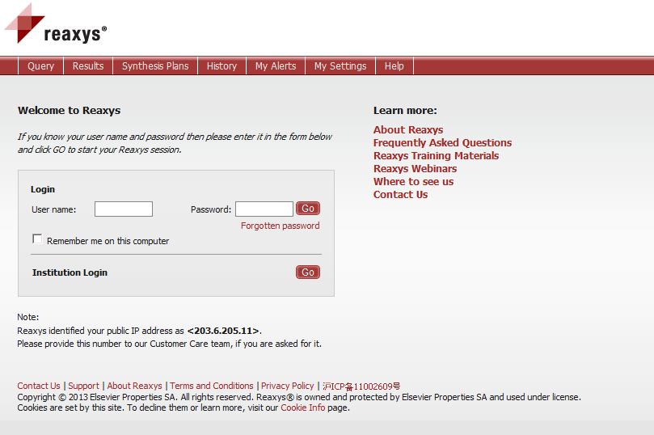
- 点击功能栏第一项“Home”（红圈处）
Click “Home” within the red circle in the function bar.
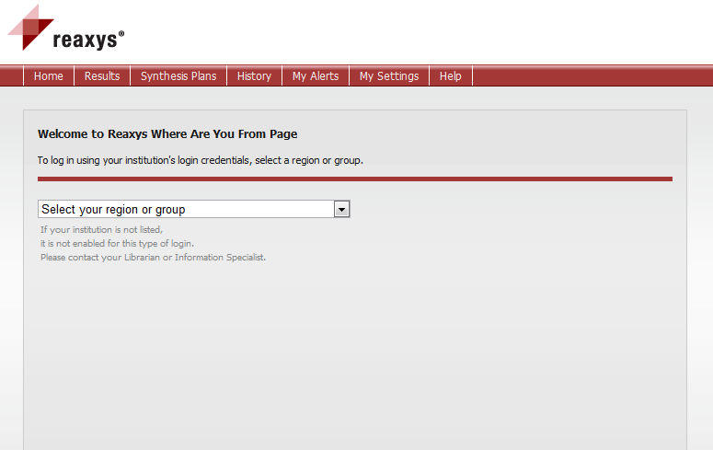
- 检查是否可以进入正式的检索页面；点击右上角红圈处可进入数据库新页面。
Check if you enter into the usual landing page, If you want, click the upper right corner to access the new interface.
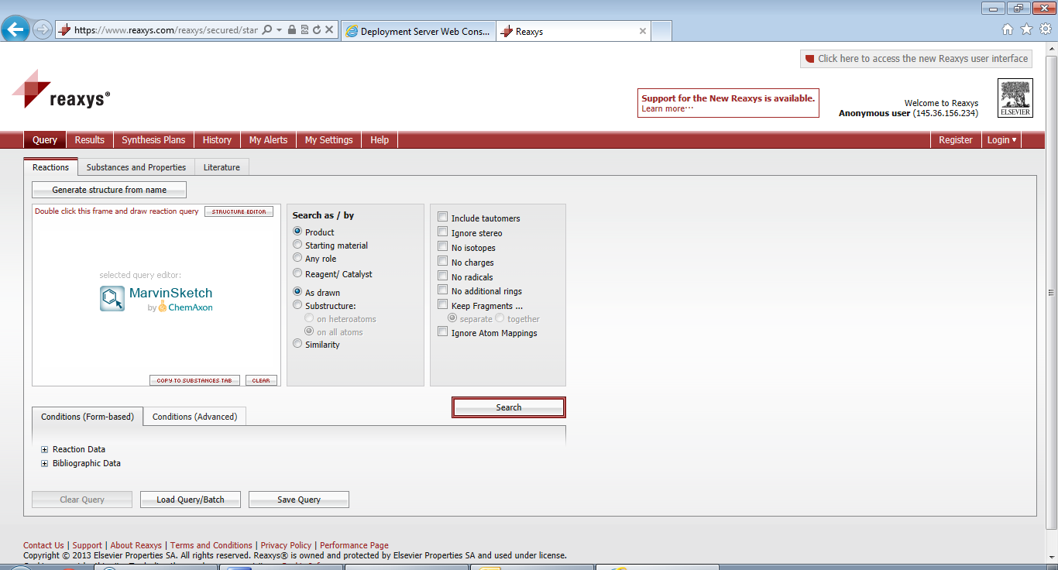
- 点击新平台右上角红圈处，可以返回旧平台页面
Click the upper right corner in the new Reaxys interface to go back to old interface.
